The Equation Chronicles: A Math RPG Game

- PROBLEM STATEMENT:

Math is an essential part of school and daily life. Its application extends to the real world, where almost everything relates to Mathematics. As they say, Math is like a universal language, uniting everyone through numbers and logic. But Math isn't always easy to learn. According to Heubeck (2025), 20% to 30% of students experience math anxiety—experiencing symptoms of anxiety, or the feeling of nervousness or fear when faced with a math problem. The teachers identify this as a serious problem as it affects the students' behavior, sometimes resulting in poor academic performance.

Another cause of students' poor academic performance is the growth of technology, specifically mobile games. The rapid spread of online games has become distracting for students as games are highly addictive. Based on a study conducted by Mahmud, S., Jobayer, M. A. A., Salma, N., Mahmud, A., and Tamanna, T. in 2023, 62.7% of students spend over 30 hours a week playing online games. This not just affects their mental and physical health, but also their academic performance. Results of playing mobile games for too long include less physical activity, less study time, and lower grades.

Many students struggle with both of these problems. Though having a hard time with Mathematics, they can't make time to study due to those addictive mobile games. Games release large amounts of dopamine in the brain, making it fun and exciting. Meanwhile, Math is not always easy, often requiring critical thinking and problem-solving skills. In this situation, games are considered an "escape", distracting them from the pressure of academics. This is why games serve as distractions that affect students' academic performances.

- PROJECT OVERVIEW
This project focuses on making a Python-based program that helps mathematics become more engaging for students who may find the subject boring. The program will present different math problems to the user in an interactive way, like quizzes, scoring, and even giving feedback, which helps students find Mathematics more motivating by practicing their skills.
The program uses basic Python programming, such as variables, conditionals, loops, and functions, to easily control the flow of the quiz and to evaluate the user's answers. Python, it can also include keeping track of the questions and scores using simple coding, like lists.
Although the program is simple, it demonstrates that programming skills can be applied to solve real-world problems in education. It shows that making a difficult subject like Math into an interactive game for the students can already improve a student’s attention span and their engagement with the subject. It highlights that even with a simple code, a problem can still be solved.

- OBJECTIVES

- To help students find enjoyment in studying Mathematics by combining fun and exciting story games with math problems, where difficulty and topics depend on the student’s grade level. This project should act as a fun learning material for Math, combining games with academics.

- To convert students’ “game time” into “study time” by combining both into one program and ensuring a 1:1 ratio of game and learning. This program allows students to play and enjoy while also learning or studying Math.

- To increase students’ voluntary study sessions by mixing games, which the new generation enjoys, with Math problems. By this, students will be entertained, building their interest in both the story and answering the Math problems, increasing the chance of more study sessions.

- To improve students’ academic performance by providing them with a program that makes learning Mathematics fun, interesting, and exciting which can decrease the rate of wrong answers for each question.

- METHODOLOGY/TECHNICAL APPROACH

METHODOLOGY:
Step 1:
When user runs the code, it will print the menu, asking for user input. User needs to pick from 1, new game, 2, load game, and 3, exit.

Step 1.1
When user picks 1, the program will ask for user's name, and lets user set a username and a password.

Step 1.2
When user picks 2, the program will ask for user's set username and password. When input is wrong, program leads user back to the menu. However, when no account has been recorded, the program will lead user back to the main menu to create account (new game).
Step 1.3
When user picks 3, the program will end.

Step 2:
After inputting the required user input, the program prints another selection. User will pick 1 if they want to play, and pick 2 if they want to go back to the main menu.

Step 2.1:
The program will print the narration of the "story". It will the ask for user's desired difficulty level, with choices grade 1-8.

Step 2.2:
Program print the main menu

Step 2.2:
The program will print the narration of the story. It will then ask for user's desired difficulty level, with choices grade 1-8.

Step 2.3:
The program will end

Step 3:
The user will input desired difficulty by grade level.

Step 3.1, 2, 3:
The game will start with addition and subtraction equations only. When the user's answer is correct, the game will continue to ask questions. The game requires 5 correct answer before flashing the main menu again. Meanwhile, when answer is wrong, the program will give user 2 more attempts on correcting their answer. When answer is wrong and attempts are finished, the user loses a life and 10 points then the program will ask another question. However, game ends when 5 questions are given. However, game ends when lives reaches 40. The program will lead you back to the main menu.

Step 3.4:
The game will start with addition, subtraction, multiplication, and division equations. When the user's answer is correct, the game will continue to ask questions. The game requires 5 correct answer before flashing the main menu again. Meanwhile, when answer is wrong, the program will give user 2 more attempts on correcting their answer. When answer is correct, program will proceed to the next question and add points. When answer is wrong and attempts are finished, the user loses a life and 10 points then the program will ask another question. However, game ends when 5 questions are given. The program will lead you back to the main menu.

Step 3.5,6,7,8:
The game will start with addition, subtraction, multiplication, division, roots, and power equations. When the user's answer is correct, the game will continue to ask questions. The game requires 5 correct answer before flashing the main menu again. Meanwhile, when answer is wrong, the program will give user 2 more attempts on correcting their answer. When answer is correct, program will proceed to the next question and add points. When answer is wrong and attempts are finished, the user loses a life and 10 points then the program will ask another question. However, game ends when 5 questions are given. The program will lead you back to the main menu.

TECHNICAL APPROACH:
In this code, python was the programming language used. Along with this, the program also made use of python’s built-in libraries such as math for the operations, random for generating the equations, and time for the tense moment in the narration. The game was mainly made of user-defined functions created and utilized by the programmer. These functions were used for generating the numbers, operations, and equations that correspond to the chosen grade level. If-else selection functions were used to create the user-defined functions. For error handling, try-and-except was used.

- FLOWCHART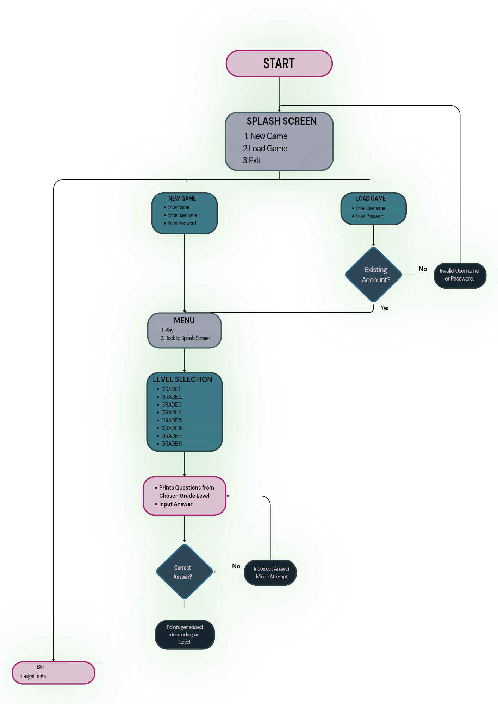

- PROGRAM

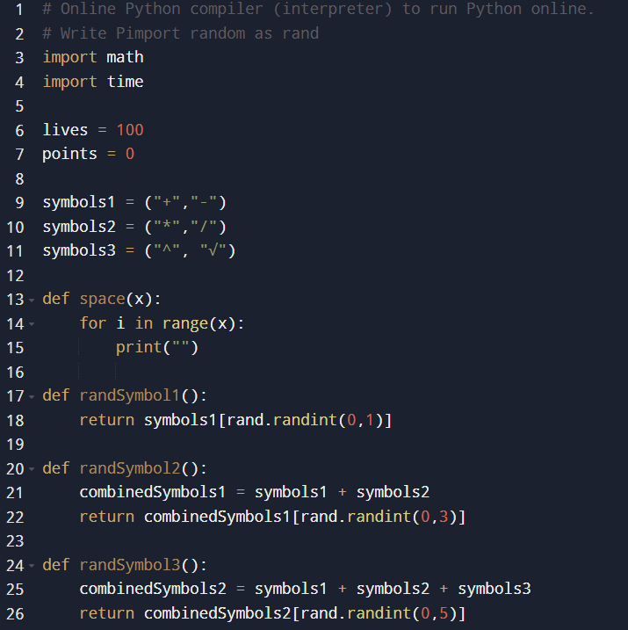
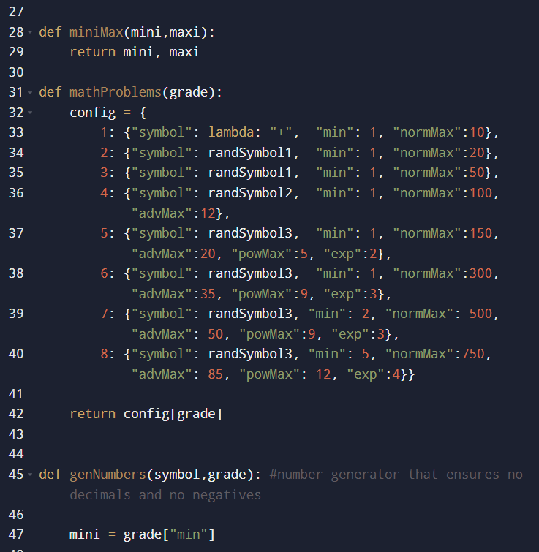
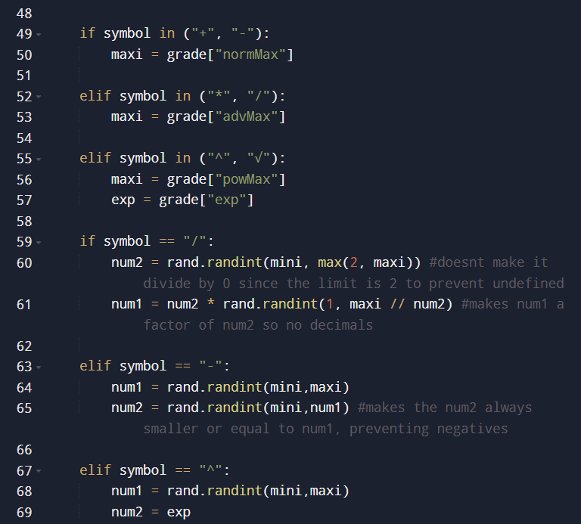
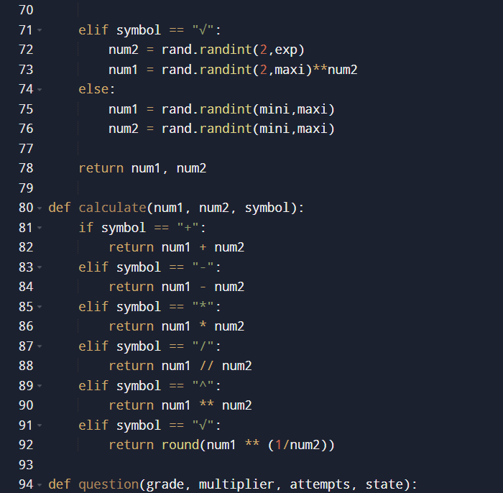
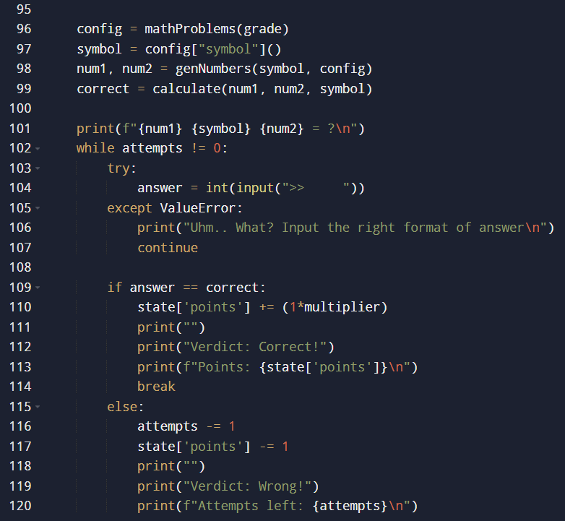
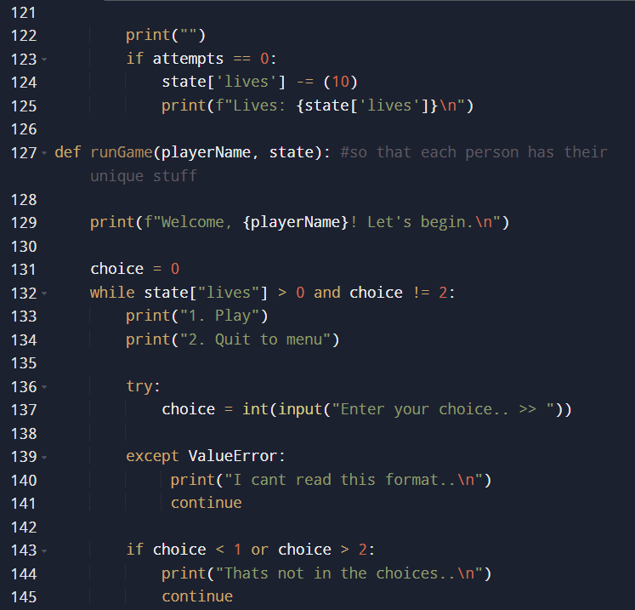
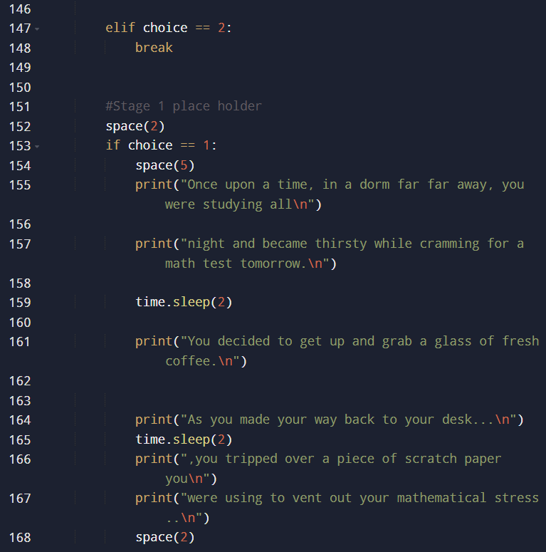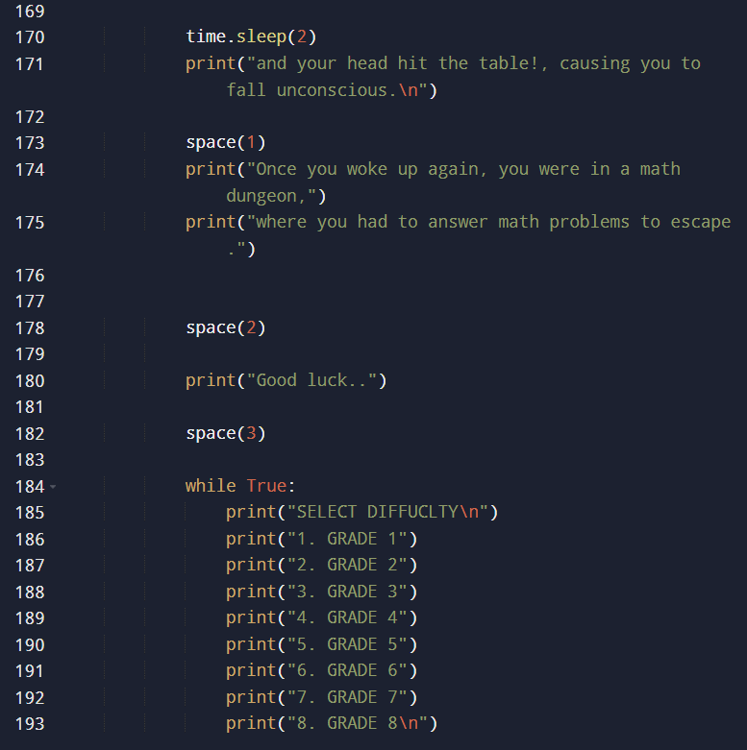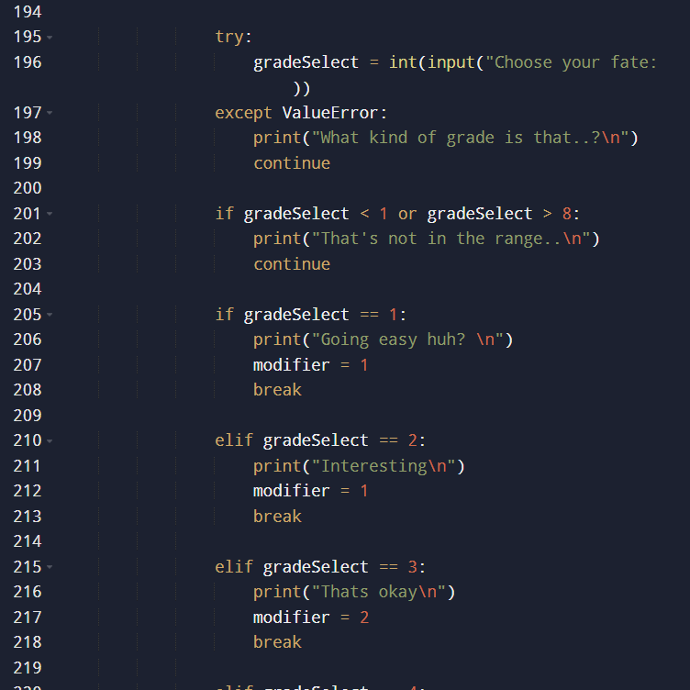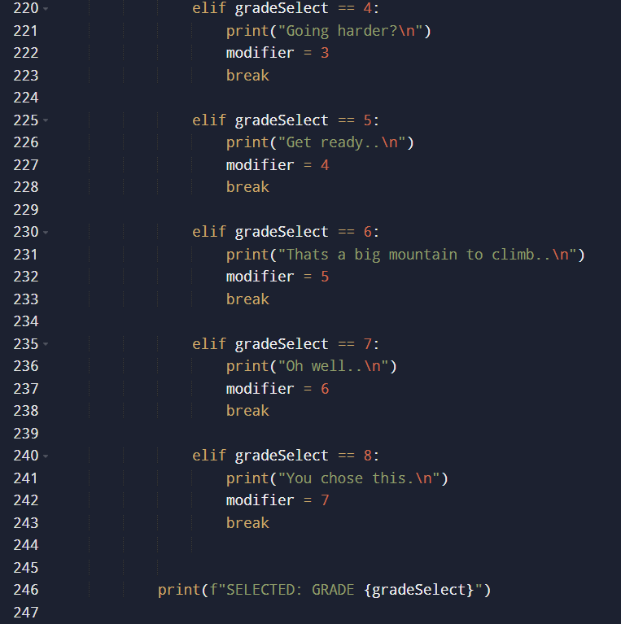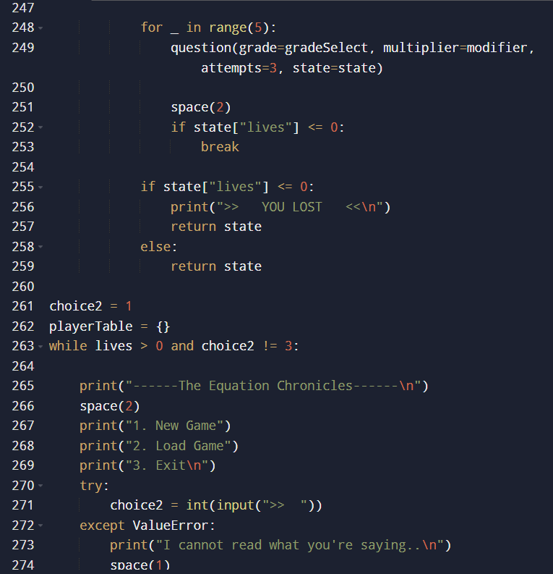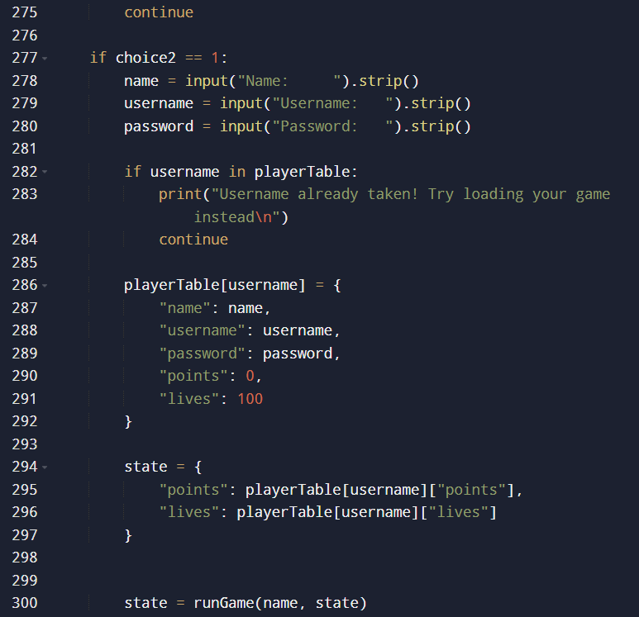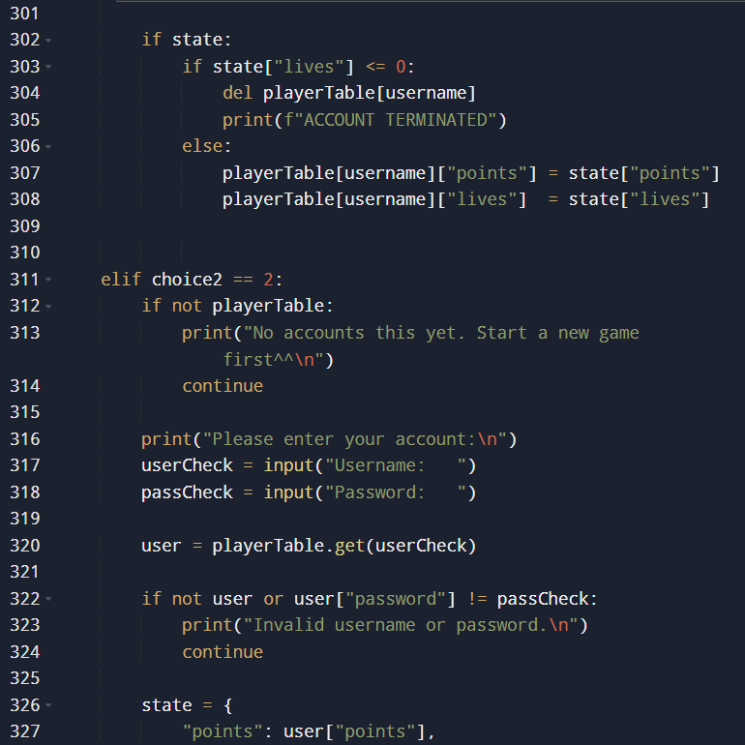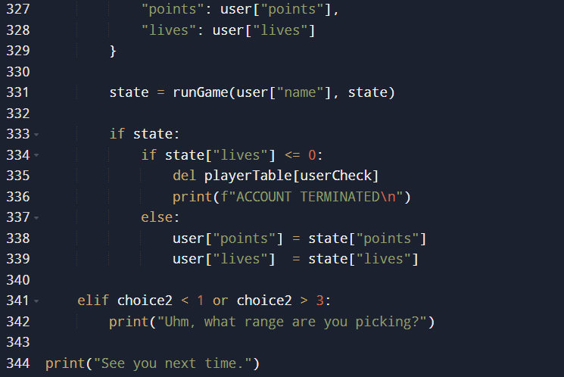
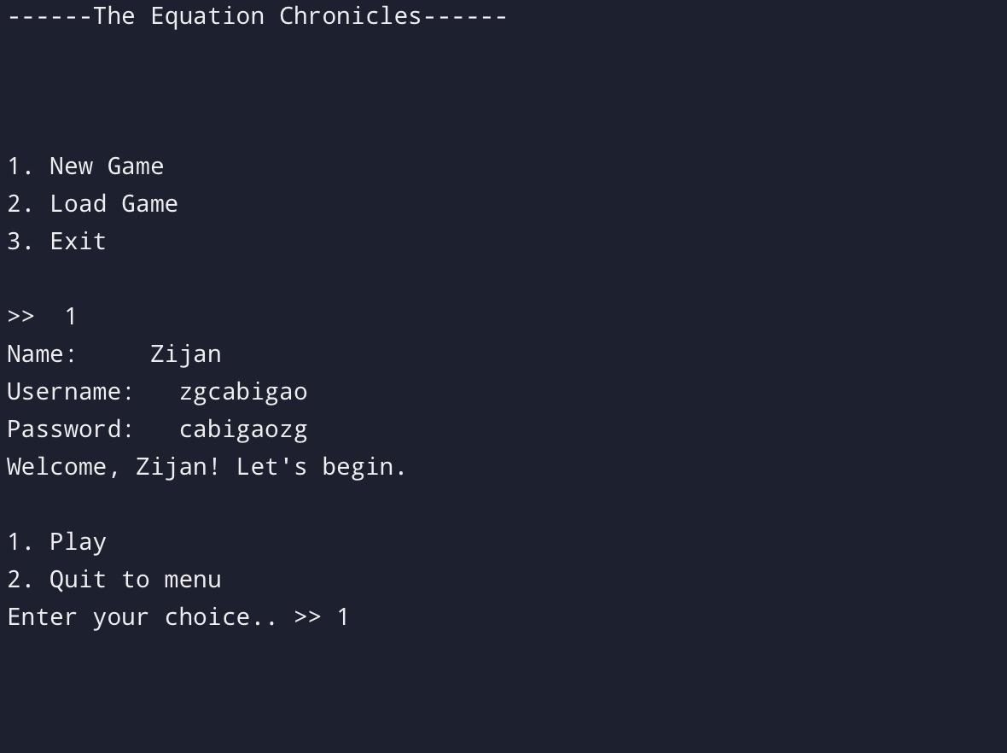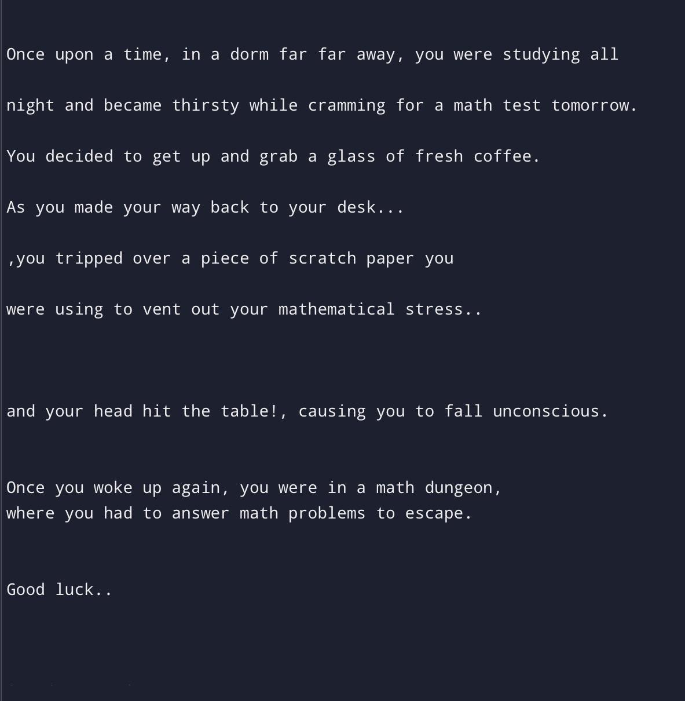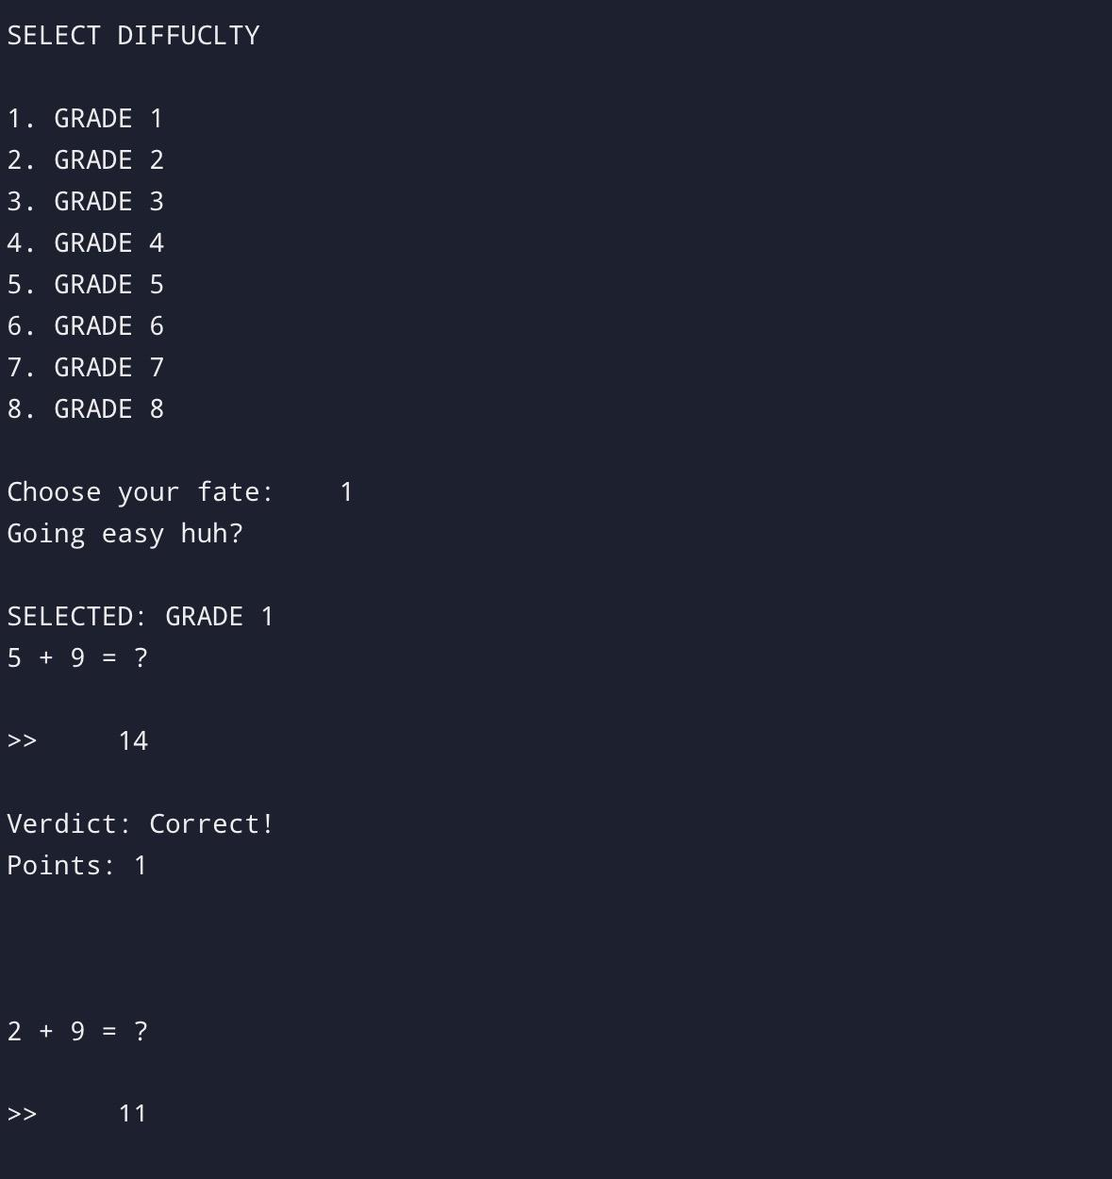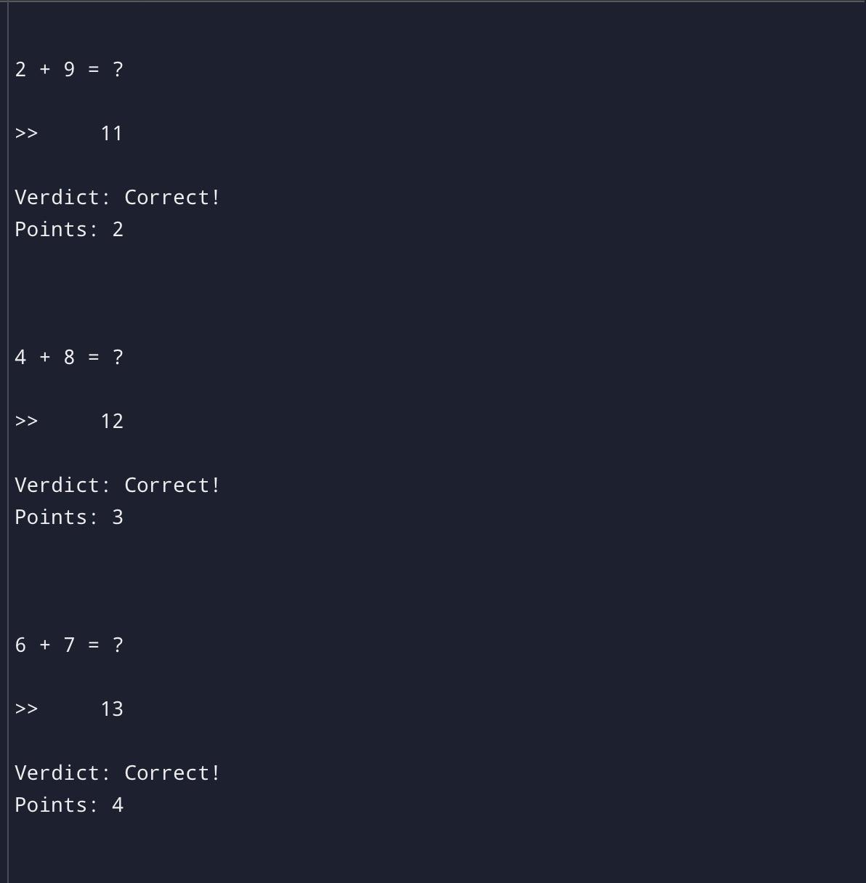
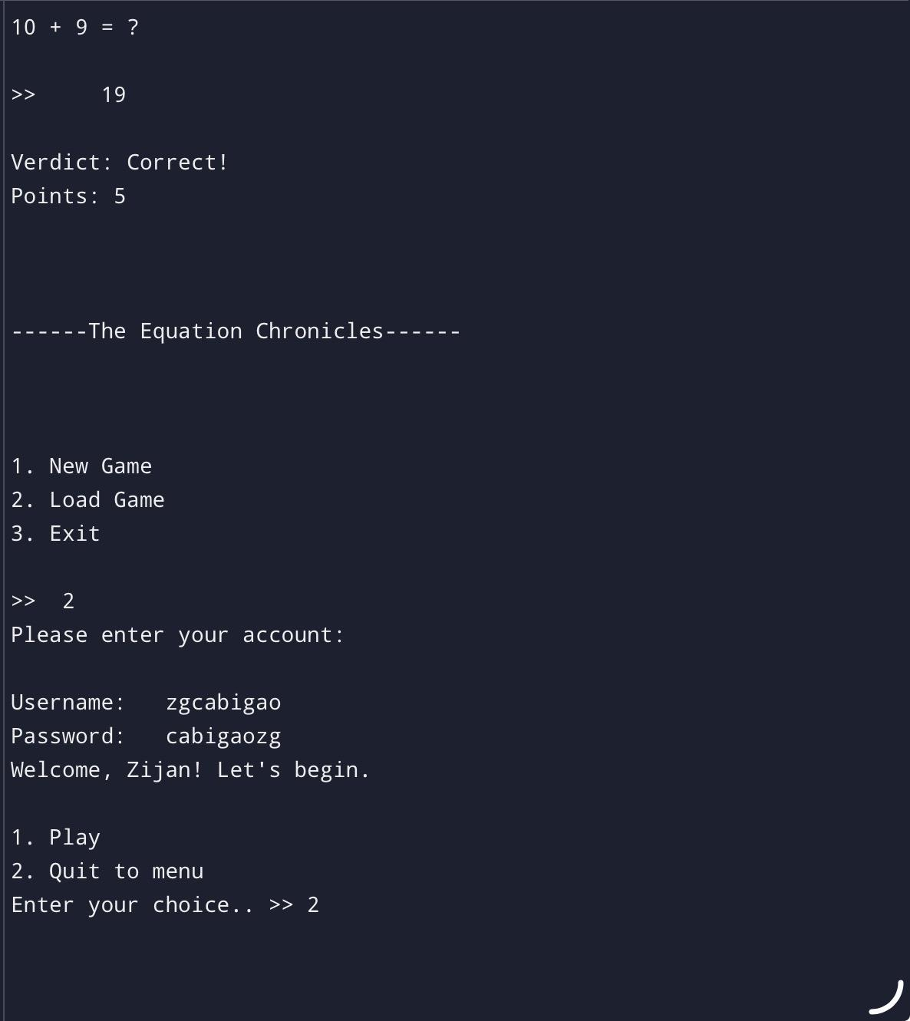
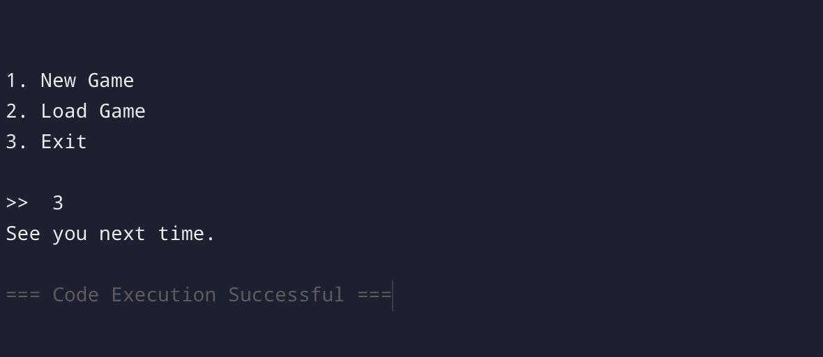

- TEAM ROLES

MEMBERS | FIRST QUARTER | SECOND QUARTER | THIRD QUARTER | FOURTH QUARTER
AYAP | Conceptualize and verify | Proofreader | Tester | Coding and debugging
BARRETTO | Conceptualizing Ideas | Writer | Writer | Final Paper and Tester
BURGOS | Conceptualizing Ideas | Writer | Tester | Final Paper and Research
CABIGAO | Coding | Coding | Coding | Coding
CASALA

- REFERENCES / BACKGROUND RESEARCH
Heubeck, E. (2025, February 24). Why so many students struggle with math anxiety—and how to help. Education Week. https://www.edweek.org/teaching-learning/why-so-many-students-struggle-with-math-anxiety-and-how-to-help/2025/02#:~:text=What%20does%20math%20anxiety%20feel,a%20challenge%20for%20their%20students.
Mahmud, S., Jobayer, M. a. A., Salma, N., Mahmud, A., & Tamanna, T. (2023). Online gaming and its effect on academic performance of Bangladeshi university students: A cross‐sectional study. Health Science Reports, 6(12), e1774. https://doi.org/10.1002/hsr2.1774

